

|  |  |
| --- | --- |
| **ANGELWINGS COMPREHENSIVE COLLEGE, MAROKO, PW, KUBWA, ABUJA** | |
| **THIRD TERM EXAMINATION 2024/2025 ACADEMIC SESSION** | |
| **SUBJECT: KUW** | **CLASS: NURSERY TWO** |

(1) Water is a liquid true/ false.

(2) Water can be used for__________________

(3) Plants give us _________ and _________

(4) Animals give us _________ and _________

(5). Animals and babies

A baby goat is called _______________.

A baby hen is called _______________.

A mother kitten is called _______________

(6). Mention two means of transport

___________________and___________________.

(7) Draw one harmful insect

(8). Draw one simple machine at home.

(9). Draw one simple machine in the classroom.

(10) Choose from the words and name the foods.

Match the name to their class of food.

Meat egg bread yam rice

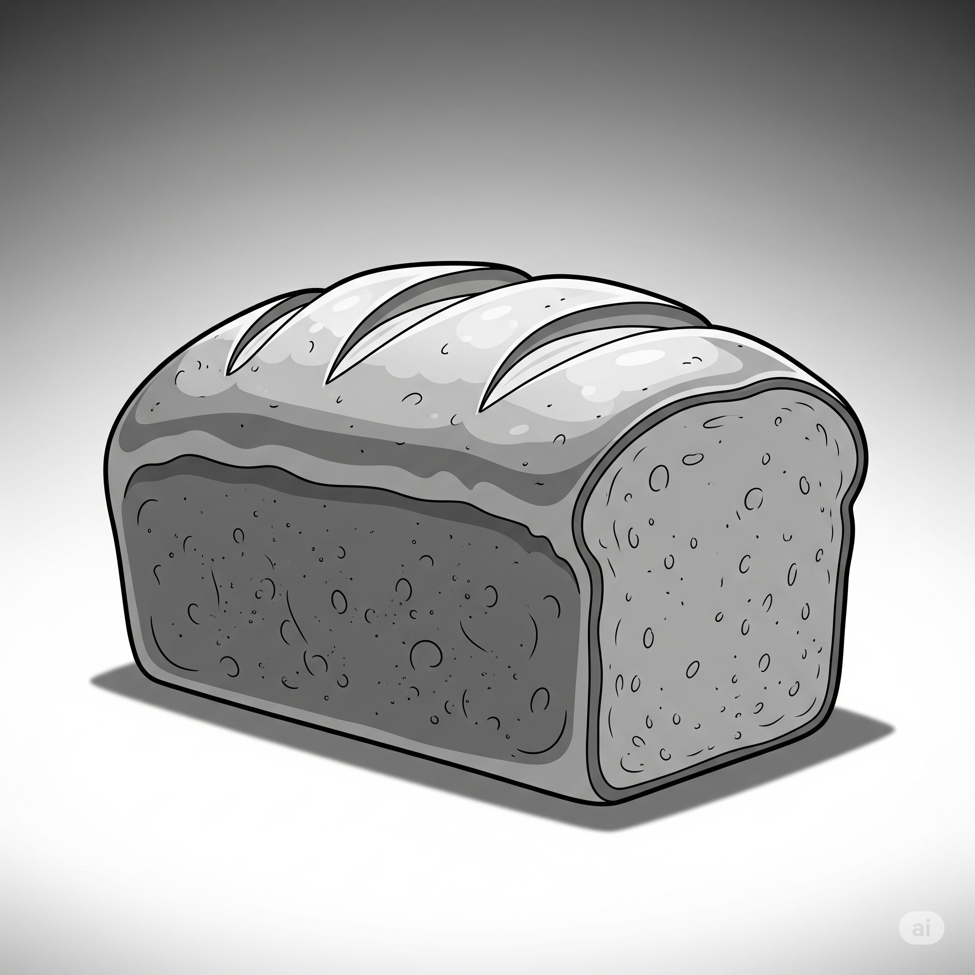

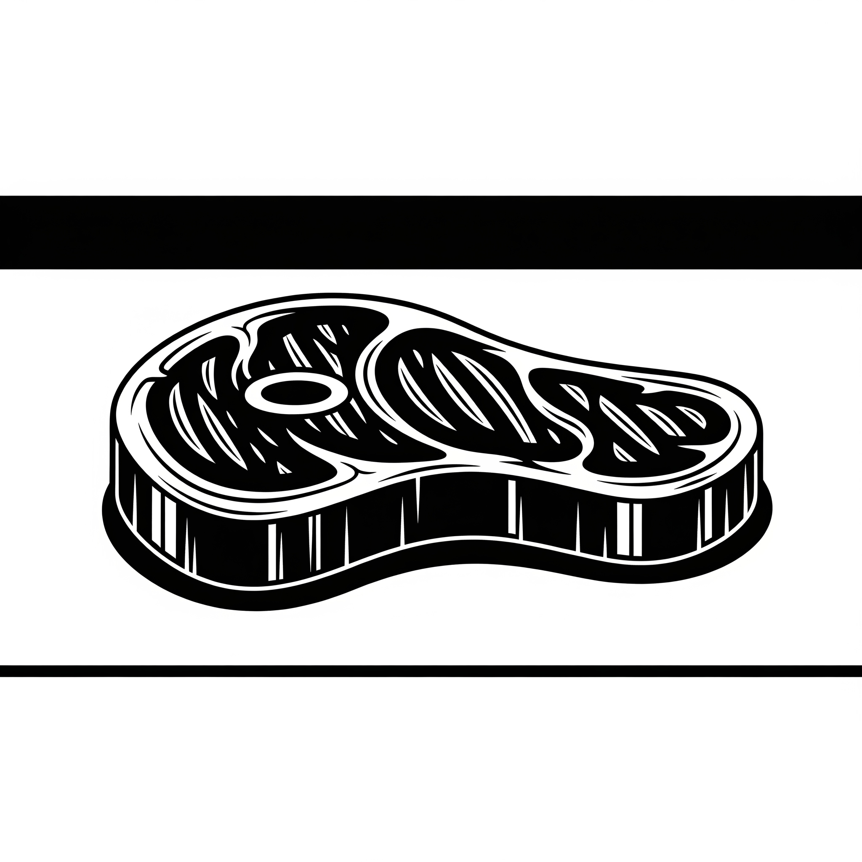 carbohydrates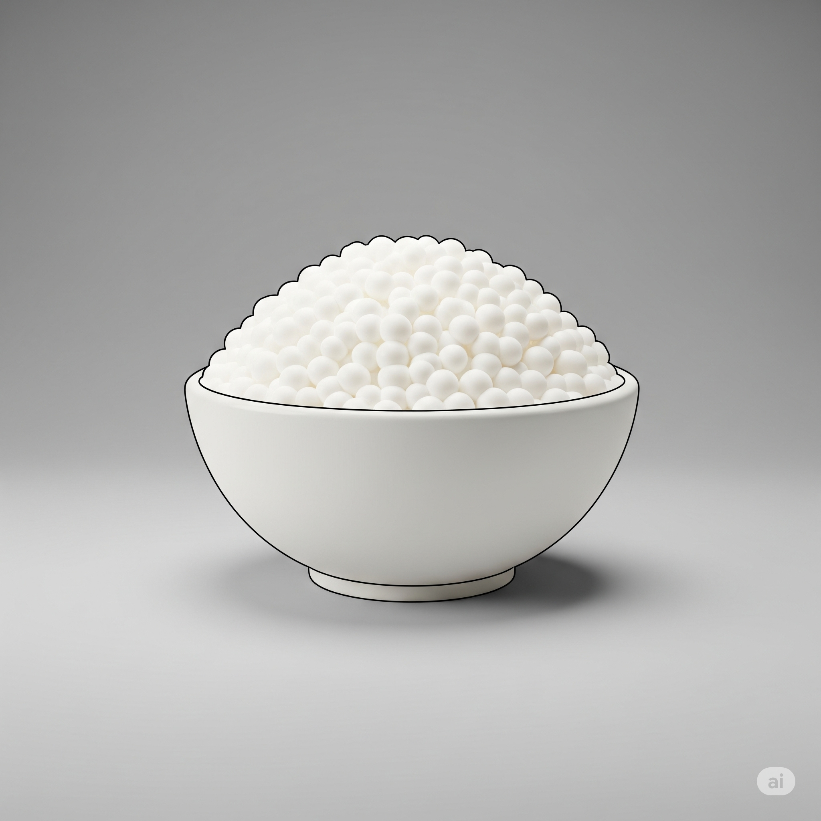 proteins

